Words and Actions Matter: Providing Gender Affirming Spaces for All
4-part Training Series
Created in collaboration with Public Health Agency of Canada, SickKids and the Community
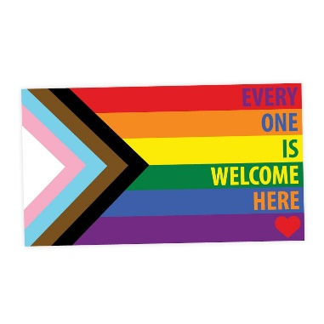
Session 1: Becoming a Safe Service Provider: The Basics
Thursday, September 15, 2022, 1-2pm EDT
Session 2: Being Affirming
Thursday, September 29, 2022, 1-2pm EDT
Session 3: Barriers to Care
Thursday, October 13, 2022, 1-2pm EDT
Session 4: Moving Forward: Our Stories
(Panel discussion facilitated by Fae Johnstone, MSW, Exec Director Wisdom2Action)
Participants: Keegan Prempeh, Michelle Edgar, Ella Lake and Donna De Filippis
Thursday, October 27, 2022, 1-2pm EDT

Developed and delivered by:
- Keegan Prempeh, BSW- Capacity Building Consultant and Community Organizer (ON)
- Logan St Croix, BA, Executive-Trans Support NL
- Michelle Edgar, BHA Hons-Community Resource Specialist Indigenous Led Crisis Response program (ON)
- Kaeden Seburn, MSW- Community Organizer, Educator, and Consultant (ON)
- Wallace Wong, Reg. Psych. (BC)

To Register: https://www.eventbrite.ca/e/405311195697
*This series will be presented in both French and English and will be recorded.

